To Create Child Processes, Execute Programs, Handle Execution Errors, Pass Arguments, Manage Parent Process, Test Command Launching

Code:
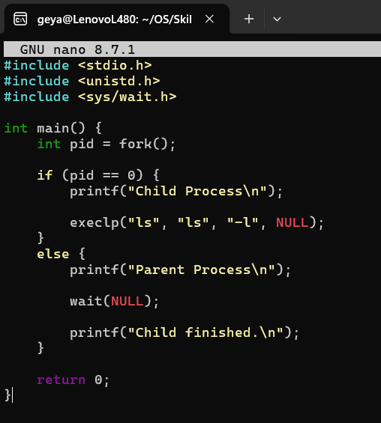

Output:
